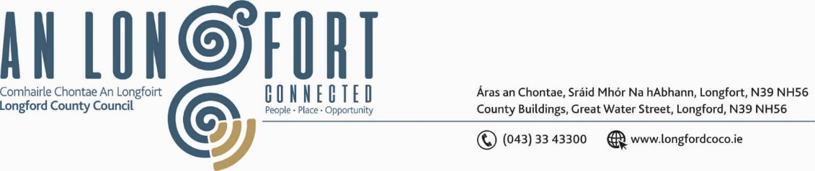

***BALLYMAHON MUNICIPAL DISTRICT***

***Please note meeting will be held in Ballymahon Library.***

**18 July 2024**

**To: Each Member of Ballymahon Municipal District.**

**Dear Member,**

You are requested to attend a Meeting of Ballymahon Municipal District to be held

**in Ballymahon Library** on **Thursday 25 July 2024 at 4 pm** to transact business, as set out on the agenda hereunder.

**Yours sincerely**,

_______________

**Claire McNabola,**

**Meetings Administrator.**

**AGENDA**

Prayer before meeting.

1. Confirmation of Minutes
2. Ballymahon Municipal District Meeting held on the 23 May 2024 – enclosed.
3. Ballymahon Municipal District Committee Meeting held on the 23 May 2024 – enclosed.

**2.** Matters arising from Minutes

**3.** Declaration of Interest by Members

**4**. Consideration of Draft Standing Orders for Ballymahon Municipal District

**5.** Management Report – enclosed

**6.** Ardagh Clock Tower

**7** Introduction to new Local Healthy Age Friendly Healthy Homes Co Ordinator

**8.** Consideration of Community Memorials Application, to commemorate Ballymahon Workhouse 1852 – 1921

**9**. Community Grants

**10**. Notice of Motions, submitted by Councillors, as listed hereunder –

**Councillor Paul Ross**

1. I call on Longford County Council to place bollards on the new footpath outside Ardagh GAA grounds to prevent dangerous parking on matchdays.
2. I call on Longford County Council to work with stakeholders to secure a new suitable site for Ballymahon Playground as the existing site is not fit for purpose and is not a safe place for children to play due to heavy littering and anti-social behaviour at the site.

**Councillor Mick Cahill**

1. Can I have an update on proposed works on the N55 on the Ballymahon side of Fowler's Bridge to deal with the road subsidence
2. I call on Longford Co council to install flashing speed signs at Taghshinny school in the interests of road safety
3. I call on Longford County Council to install additional traffic calming signs to create greater awareness to motorists in Kenagh particularly at the School

**Councillor Martin Skelly**

1. I call on Longford County Council to repair the fencing and upgrade same at Cashel graveyard in the interest of public safety.
2. I call on Longford County Council to install traffic calming measures at Cloontagh School and Derryhaun cross as these are prone to speeding traffic.

**Councillor Pat O’Toole**

1. I call on Longford County Council to assess the feasibility of carrying out some remedial work on the L1120 in Forgney (The Ballymore Road) with the view to lowering a blind spot on the road and erecting a safety barrier on the same stretch of road. The work to be considered under a Low-Cost Safety Improvement Scheme or have the work included in next year's roads programme